Unicorn Horns: How Storytelling Transforms Museum Experiences

https://medium.com/@MuseumHack/unicorn-horns-how-storytelling-transforms-museum-experiences-d20a142220eb

It’s my first time at the Metropolitan Museum of Art. Braving the crowds, I wander hallways filled with Late Roman and Byzantine art. I’ll end up perusing this hallway several times, until I notice Gallery 302, Byzantine Egypt. It’s in here, tucked in slightly darkened spaces, that I find books, textiles, and monumental stone carvings from places I’ve only heard in passing, like Saqqara. What did they do there? How did they live? Did they love, dream, and pray like I do, or were their lives so different that I wouldn’t recognize them?
These questions follow me all day. I’ll end up wandering Prehistoric and Greek statues placed on glass shelves, Medieval armor staged to look as if it’s marching, and period room after period room of lavish furnishings or cloistered chapels. All begging to be heard, to be felt, to be lived again. And yet, I find no information that fosters personal connection. I feel affinity for some objects, like when I’m standing in front of Hatshepsut wondering if she was happy, but I never feel like I know her.
Later that evening, I’m on tour with Museum Hack. It’s my second time on tour with them, and the first time that I’ll be presenting an object during the tour. I’ve never done this. I’m nervous as hell and wondering why, in all my museum training, this was never asked of me.

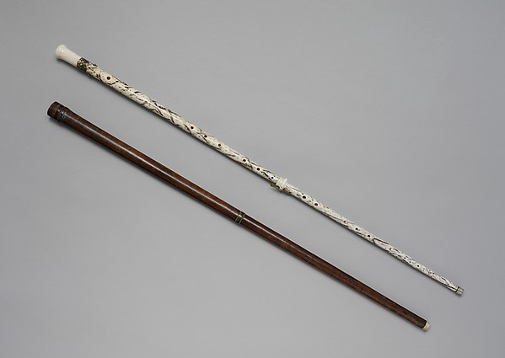
It’s a walking stick, flute, oboe…and unicorn horn?
But before I present, we stop in the musical objects gallery. We’re standing in front of a case filled with instruments, and it’s the first time I’ve seen any of this. Musical instruments aren’t really my thing. Then the guide starts talking. Turns out, the white walking-stick in the case is a flute/oboe made from the horn of a narwhal — which, back in 1750, would have been considered a “unicorn of the sea.” I’m laughing because it seems so silly. The guide invites one of the girls on tour to engage with him, diving into a dialogue about how this walking-stick flute/oboe could have been used to court a woman into marrying a noble. I mean, c’mon, what girl in the 18th century wouldn’t agree to marry a fabulously wealthy man who just showed off his killer flute/oboe skills with a “unicorn horn”?
The guide’s methods bring to mind an article I’d read some time ago, “Constructing a Cultural Context through Museum Storytelling” by Margaret DiBlasio and Raymond DiBlasio. Published in 1983, their article examined an exhibition on the Vikings at the Minneapolis Institute of Arts and the Metropolitan Museum of Art, and how that exhibition utilized storytelling to connect with schoolchildren. Their seven principles of storytelling still resonate today — and not just for children. Right now, during an energetic evening at the Met, I’m living them:
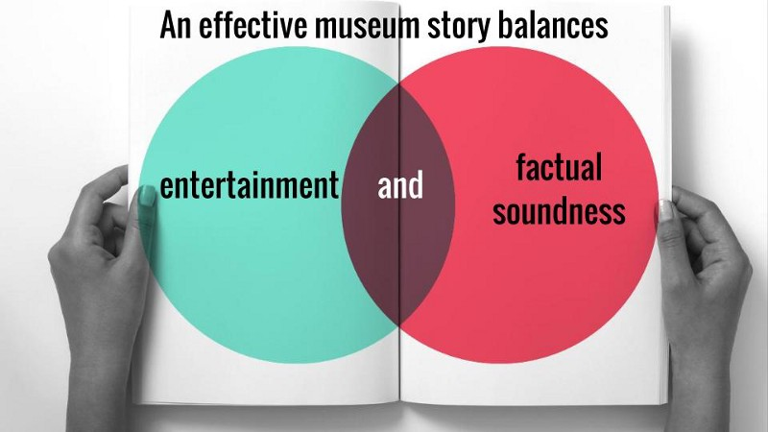
I’m not really sure if Georg Henrich Scherer, or the nobles who used this walking-stick, really thought it was a unicorn horn. But beyond that, I can imagine the entire story playing out as it’s being told. It’s funny, witty, and filled with ideas about how courtship could be conducted that never dawned on me before. And for the first time in my life, I want to hear what this flute/oboe sounds like. I don’t even like flutes and oboes.

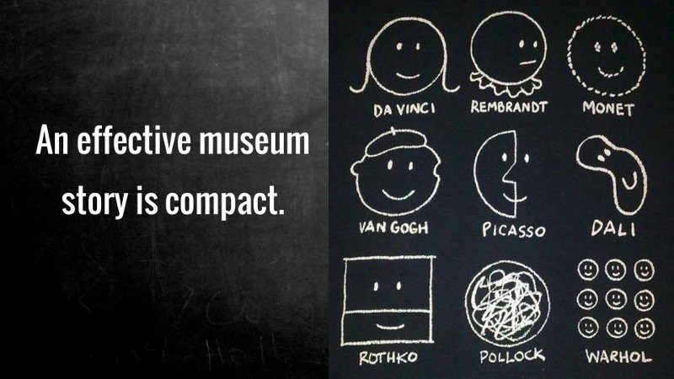
This story doesn’t last more than what feels like five minutes. I have no idea how long we actually stood (or sat) listening, but it’s over so quickly that I never get bored. And we’ve only lived a few hours of time in the 1750s, enough for one man to make the girl of his dreams agree to marry him.

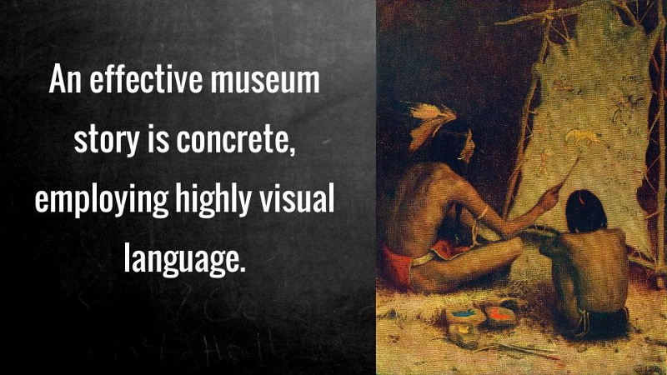
Without ever removing the artifact from behind its glass case, I learn how it was adjusted to become a flute, an oboe, or a walking stick. I watch the guide’s hands move as if he is playing the instrument and as he takes the girl’s hand to court her. His words and movements hint at walking, playing, courting. I feel like I could pick up this object and use it as was done nearly 300 years ago.

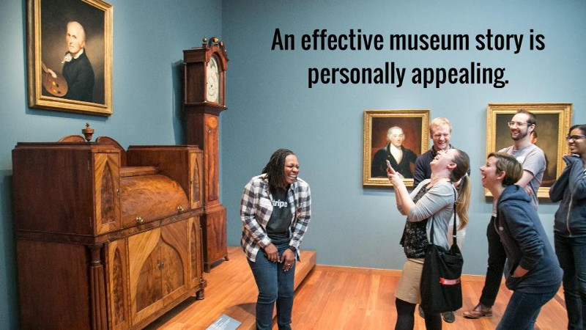
As I’m listening, I’m remembering how I’ve been courted during my life. Whether it was flowers, fun dates, or other displays of affection, my life isn’t so far off from this girl’s experiences. I identify with her — not at the end of the story, but throughout it, and that deepens my appreciation for the object and the people to whom it meant something.

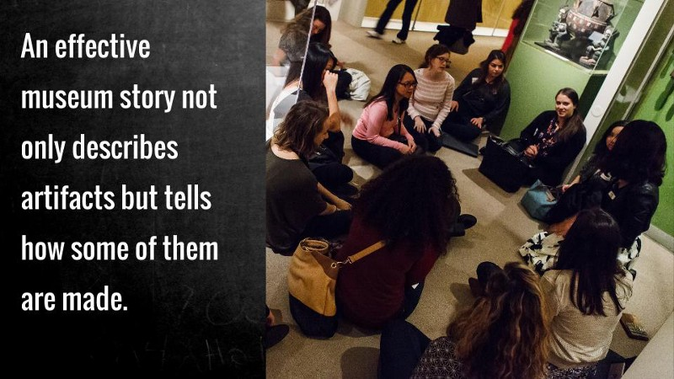
Part of this object’s story is how it was acquired. It began with a brief glimpse of how sailors would hunt narwhals and claim them to be the “unicorns of the sea” in order to sell them for major money to high-ranking nobles. I also learn that only two of these walking-stick flute/oboes exist in the world today: and this is the only one on public display. It’s a brief part of the story, but a key part, because I understand the full journey of how this object came to be.

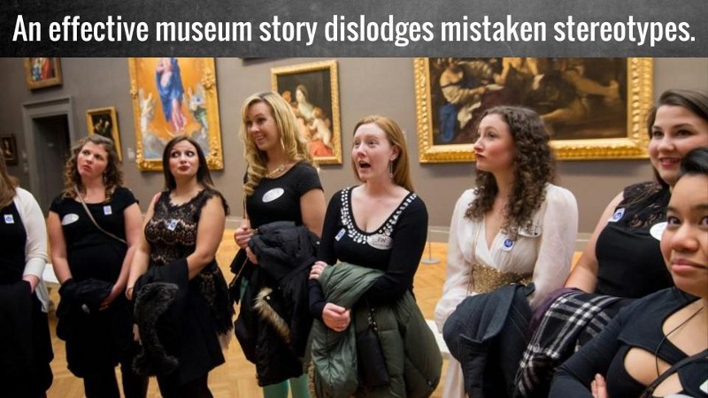
As the De Blasio’s stated, “We must not imagine that our stories are filling vacuums.” Coming into this tour, I knew a bit about courtship in the nobility. The story I heard expanded on what I already knew. The story also never implied that our group didn’t know about courtship or narwhals or music — it just invited us to discover this one unique story.

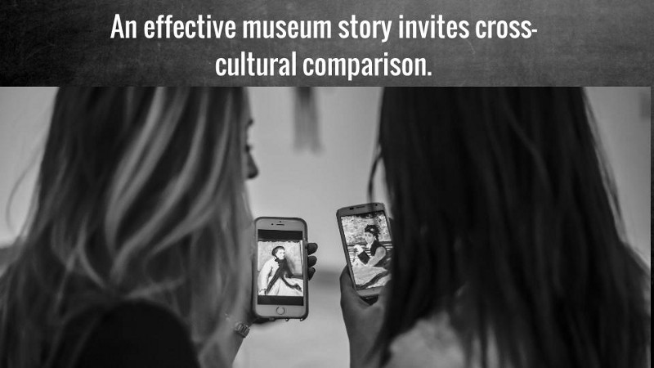
The story was also an invitation to consider how modern displays of affection compare with those of other centuries and cultures. I felt personal connection with the woman in the story. My modern experiences felt akin to her 18th-century ones, and through that story I was able to make connections and comparisons to my own life. Now, when talking about weird dates or amazing displays of affection, I’m reminded of the walking-stick flute/oboe “unicorn horn” and excited to share that story.
Throughout my tour, I was invited to view art not as these pedestal-placed examples of high taste, but as objects that tell uniquely human stories. The objects became more than something behind a glass case: they came alive.
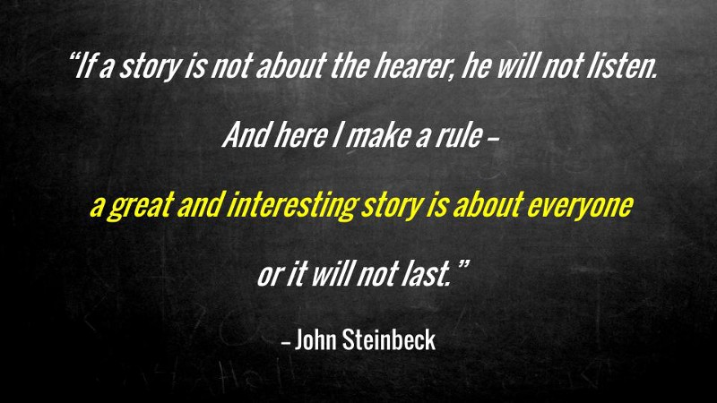
Then it’s my turn. Standing in front of a recreated Versailles bedroom, I’m telling the story of Marie Antoinette and her affair with Count Axel von Fersen. It’s a story of love, lust, and personal sacrifice. From the audience’s reactions, I can tell that at least some of the ladies understand how Marie was so in love with Axel. My story is a blend of facts and personal reflections on what it meant to be the queen of France, to have your whole life on public display, but to still chase after that elusive, but uniquely human, need for intimate love. By the end, I’ve achieved something I’ve wanted since I started my career: I’ve brought history to life, and helped others feel as passionately about Marie Antoinette’s bad reputation as I do.
Both are stories I won’t soon forget — and testaments to how effective storytelling, filled with passion and excitement, can transform a museum visit into a museum adventure.
Tiffany Rhoades is Audience Development Assistant for Museum Hack, where she coordinates professional development services, publications, and social media. She has also worked with Girl Museum, the Blowing Rock Art & History Museum, Theodore Roosevelt Center, and other museums to develop programming, exhibitions, partnerships, and collections. A public historian, Tiffany specializes in creating engaging experiences through storytelling, multimedia, and community collaboration.

